

Semester One Examination, 2020

Question/Answer booklet

SPECIALIST MATHS
UNIT 3

Section One:

Calculator-free

Your Name

Your Teacher’s Name

Time allowed for this section
Reading time before commencing work: five minutes
Working time: fifty minutes

Materials required/recommended for this section
To be provided by the supervisor
This Question/Answer booklet
Formula sheet

To be provided by the candidate
Standard items: pens (blue/black preferred), pencils (including coloured), sharpener, correction fluid/tape, eraser, ruler, highlighters

Special items: nil

Important note to candidates
No other items may be taken into the examination room. It is your responsibility to ensure that you do not have any unauthorised material. If you have any unauthorised material with you, hand it to the supervisor before reading any further.
Question | Mark | Max | Question | Mark | Max
1 | 6 |  | 5 | 5
2 | 10 |  | 6 | 8
3 | 9 |  | 7 | 9
4 | 3

Structure of this paper

Section | Number of questions available | Number of questions to be answered | Working time (minutes) | Marks available | Percentage of examination
Section One:  Calculator-free | 7 | 7 | 50 | 50 | 33
Section Two:  Calculator-assumed | 10 | 10 | 100 | 100 | 67
 |  |  |  | Total | 100

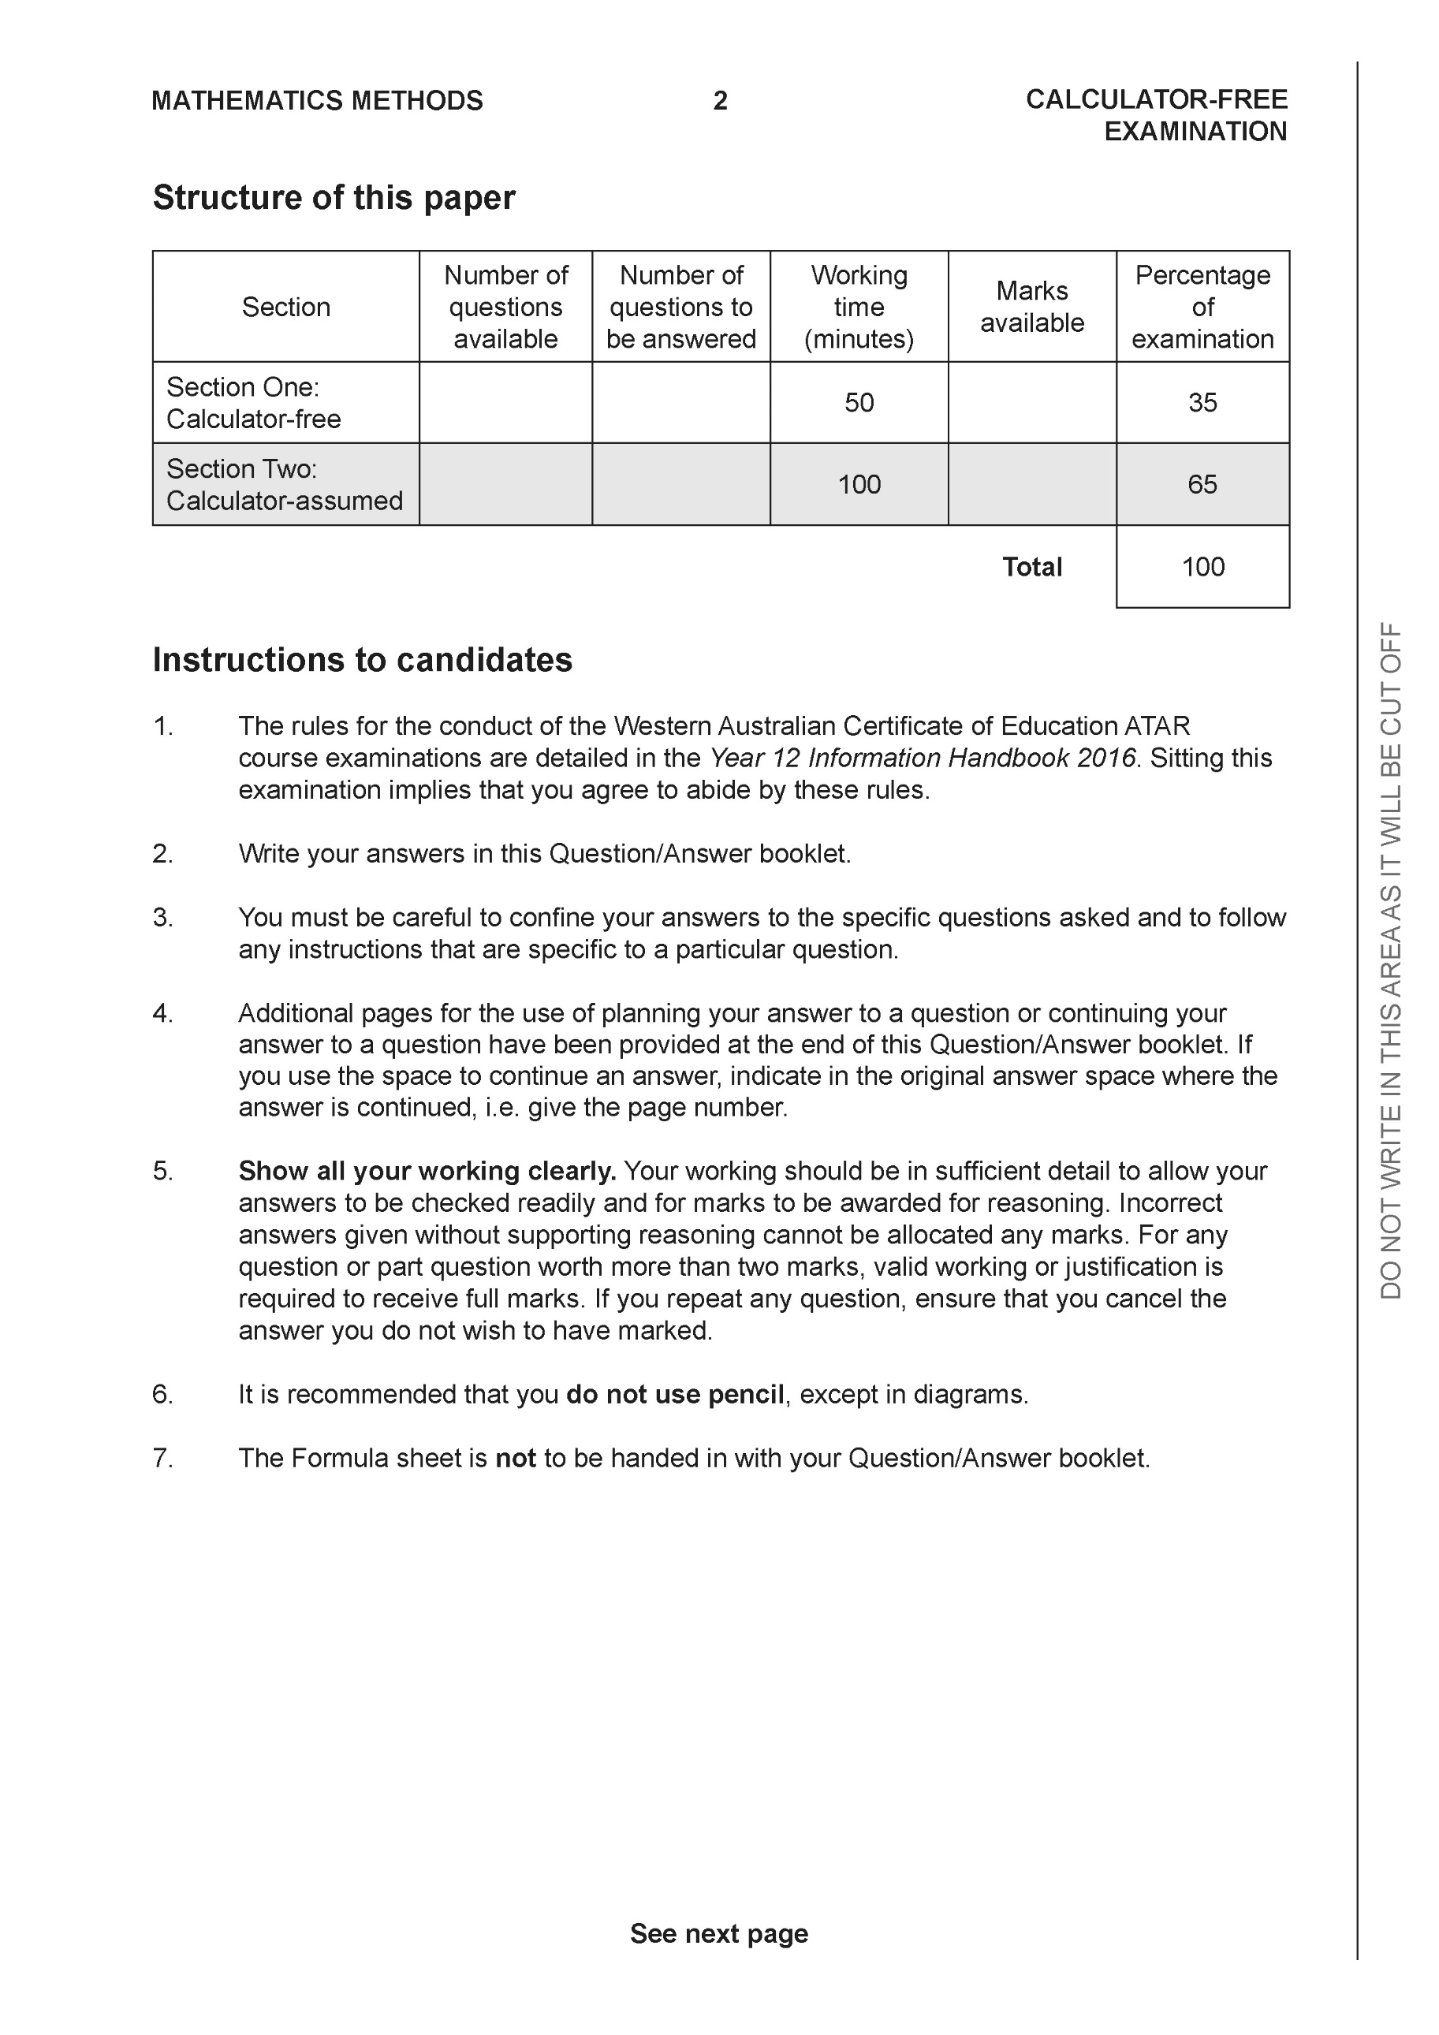

Section One: Calculator-free (50 Marks)

This section has seven (7) questions. Answer all questions. Write your answers in the spaces provided.

Spare pages are included at the end of this booklet. They can be used for planning your responses and/or as additional space if required to continue an answer.
● Planning: If you use the spare pages for planning, indicate this clearly at the top of the page.
● Continuing an answer: If you need to use the space to continue an answer, indicate in the original answer space where the answer is continued, i.e. give the page number. Fill in the number of the question that you are continuing to answer at the top of the page.

Working time: 50 minutes.

Question 1 (6 marks)

Consider the polynomial .
(a) Determine (1 mark)

(b) Show that is a factor of . (2 marks)

(c) Determine all the roots to (3 marks)

Question 2 (10 marks)

Consider the functions & .
- Determine the natural domain and range of . (2 marks)

- Determine the rule for and state its natural domain and range. (3 marks)

- Determine the rule and natural domain for . Explain why the composite exists.
(3 marks)

- Does ? Justify. (2 marks)

Question 3 (9 marks)

Consider the function which is drawn below and defined only for .

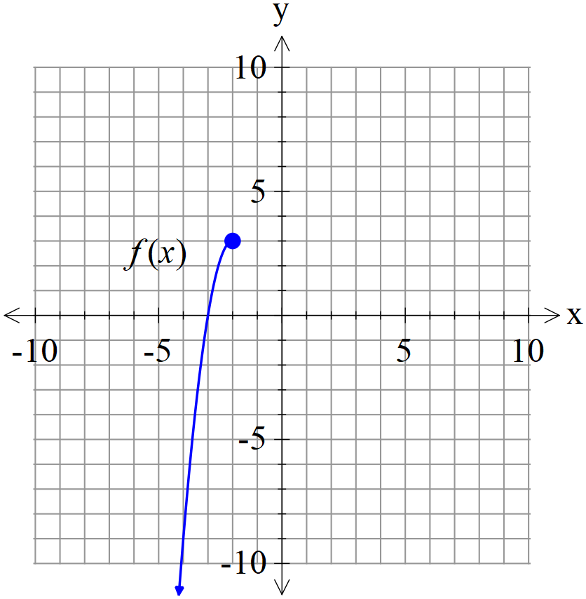

- Sketch on the axes above. (2 marks)

- Given that , determine the rule for and state the domain and range. (4 marks)

- Determine the exact solution(s) to if any. (3 marks)

Question 4 (3 marks)

Consider the complex equation for any positive integer . The roots are designated .
Let , determine for any positive integer .Explain.

Question 5 (5 marks)

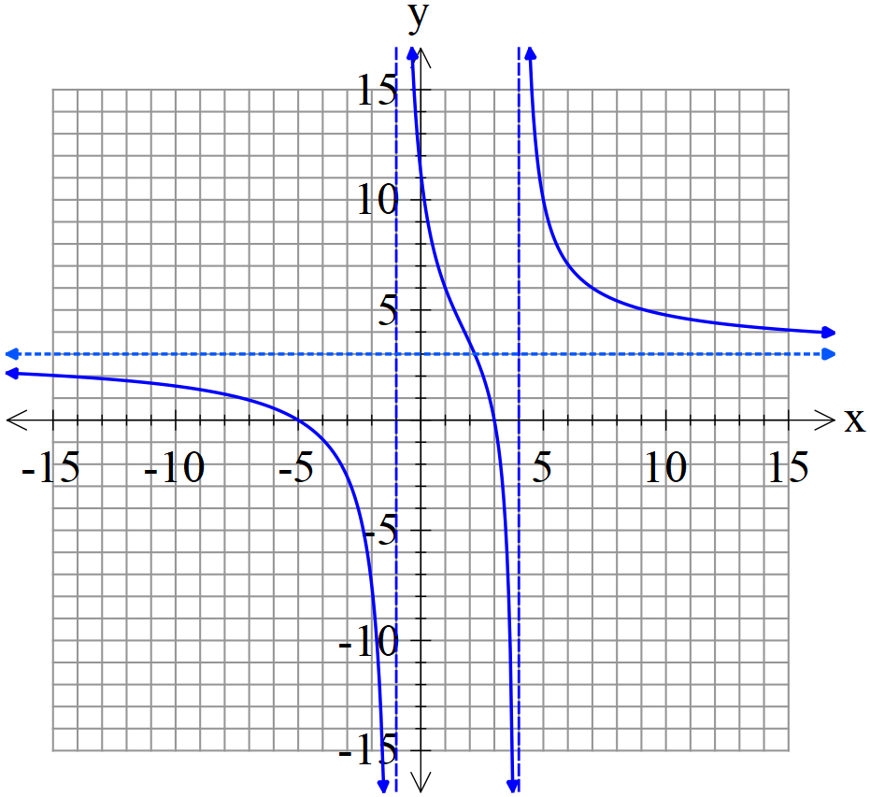 | The function is drawn to the left where are all integers.

Complete the following table.
a | b | c | p | q

Question 6 (8 marks)

Consider the function which is drawn below and is defined for .

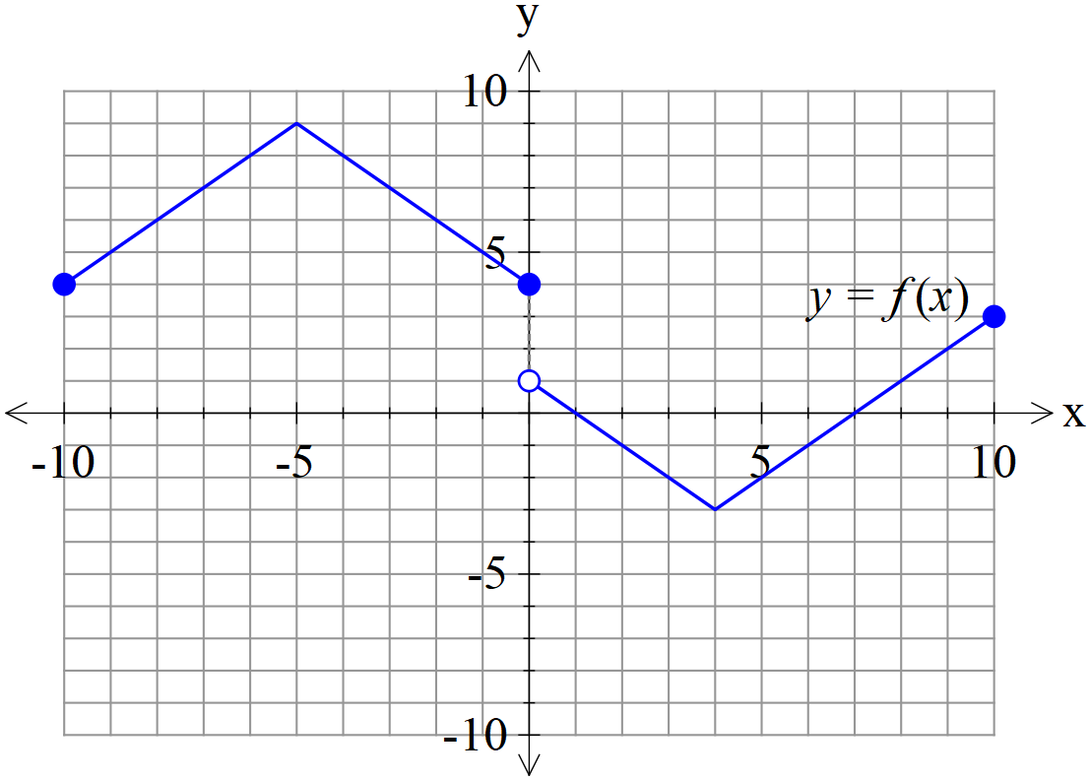

(a) Sketch on the axes below. (2 marks)

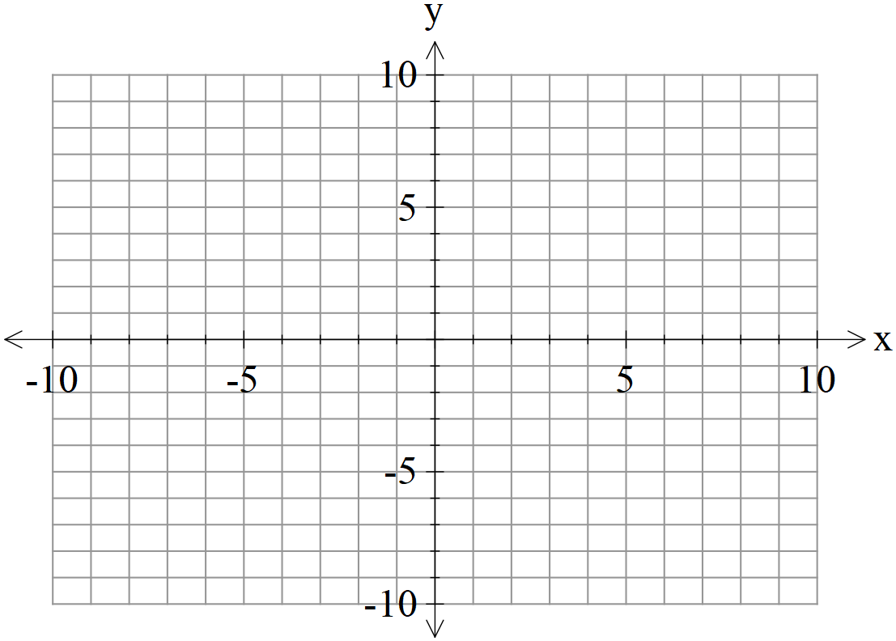

(b) Sketch on the axes below. (3 marks)



(c) Sketch on the axes below. (3 marks)



Question 7 (9 marks)

Consider a projectile that has an initial speed, , at an angle of with the horizontal
that moves with an acceleration of where is a constant.

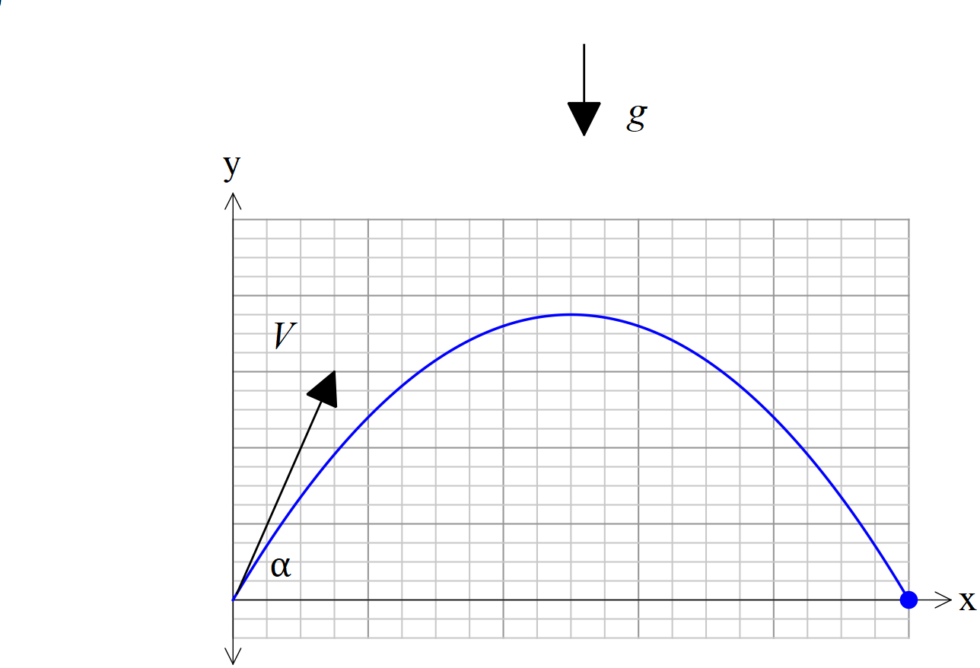

- If the projectile begins at the origin, show that a time, , and using vector calculus that the velocity vector is given by: (2 marks)

- In terms of derive the cartesian equation of the projectile. (4 marks)

Q7 cont
- Given that derive the following equation.
. (3 marks)

